Edited in 24th Jan 2025
A study to assess correlation between
screen time and sleep quality among students
at selected nursing institute of Pune city

ABSTRACT

Introduction: Sleep is an essential physiological process crucial for physical, cognitive, and emotional well-being. Increased screen time, particularly before bedtime, has been linked to sleep disturbances in many studies. Nursing students are especially vulnerable due to academic workload, irregular schedules, and extensive use of digital devices. This study aimed to assess sleep quality, evaluate screen time, and examine the correlation between screen exposure and sleep quality among nursing students. Objectives: 1. To assess the sleep quality among college-going students. 2. To evaluate screen time among students. 3. To determine the correlation between screen time and sleep quality. Methods: A quantitative, descriptive correlational study design was approached. Data was collected from 70, third year GNM students at Maharshi Karve Stree Shikshan Samstha’s Bakul Tambat Institute of Nursing Education, Pune. The research tool included Demographic Data, Pittsburgh Sleep Quality Index (PSQI), and Structured Screen Time Assessment Questionnaire. Data were analysed using descriptive statistics (frequency, percentage, mean, SD) and inferential statistics (Pearson’s correlation coefficient)( p < 0.05.) Results: Majority of students were aged 20–21 years (68.57%) and resided with families (52.85%). Sleep assessment showed 42.85% with moderate difficulty, 27.14% with severe difficulty. Smartphones were the most used device (85.5%), with social media being the primary activity (62.9%). The correlation analysis revealed a weak positive correlation (r = 0.08) between screen time and PSQI scores, which was not statistically significant (p > 0.05). This indicates that, in this sample, screen time was not a strong predictor of sleep quality. Conclusion: Although a large proportion of nursing students experienced poor sleep quality, screen time did not show a significant correlation with sleep quality. This suggests that sleep disturbances are likely multifactorial. Health education on screen hygiene and sleep practices is recommended to improve well-being and academic performance.

Keywords: Screen time, Sleep quality, Nursing students, PSQI, Correlation

I. INTRODUCTION:

In the 21st century, digital technology has become a big part of everyday life. People use smartphones, laptops, tablets, and televisions not only for chatting and fun but also for learning, working, and staying in touch with others. More and more people, from kids to older adults, are relying on these gadgets, and it’s changing the way everyone lives. Among all age groups, young adults and college students are the most affected. They have to manage school, friends, and personal matters, which makes them more exposed to screens. The term “screen time” means how much time someone spends using devices with screens, like televisions, computers, laptops, and smartphones.¹
Using screens in a balanced way can be good for education, communication, and sharing information. For example, digital tools help students find online lessons, talk with classmates, and learn new skills. But when screen use is too much and not controlled, it becomes a serious health issue. The World Health Organization (WHO) and the American Academy of Paediatrics suggest that teenagers and young adults should not spend more than two hours a day on recreational screen time.² However, most students go beyond this limit, and smartphones are the main reason for this.
Across the globe, the prevalence of poor sleep quality among adolescents and young adults has been on the rise. The World Health Organization (WHO) recommends that young adults should sleep at least 7–9 hours daily, while recreational screen time should be limited to not more than 2 hours per day.³ However, multiple studies have shown that actual usage far exceeds these limits. A systematic review and meta-analysis of 55 studies with more than 21,000 participants across countries like Germany, the United States, and India demonstrated a strong association between electronic media use and poor sleep quality.⁴
More time spent on screens affects the quality of sleep for students today. Even though digital tools help with communication and learning, using them too much can mess up sleep schedules, especially for young adults and nursing students. Hence, the objective of the study was to assess the effect of screen time on sleep quality among nursing students.
II. METHODOLOGY:
A quantitative approach and descriptive correlational research study design were adopted. The data was collected from 60 third-year GNM students from a nursing institute in Pune city. The consent was taken from the samples. The sampling technique employed by the study was a non-probability purposive sampling technique. The research tool included: Demographic Data, Pittsburgh Sleep Quality Index (PSQI), and Structured Screen Time Assessment Questionnaire.
III. RESULTS/ FINDINGS:
This section deals with demographic data, sleep quality and screen time and its correlation among nursing students. The majority of students were aged 20–21 years (68.57%) and resided with families (52.85%). Sleep assessment showed 42.85% with moderate difficulty, 27.14% with severe difficulty, and only 1.42% reporting no difficulty. Smartphones were the most used device (85.5%), with social media being the primary activity (62.9%). The correlation analysis revealed a weak positive correlation (r = 0.08) between screen time and PSQI scores, which was not statistically significant (p > 0.05). This indicates that, in this sample, screen time was not a strong predictor of sleep quality. Other factors such as academic stress, lifestyle, and environmental conditions may have influenced outcomes.

Table 1. Frequency distribution of sleep quality
N=70
S.N. | SLEEP QUALITY | FREQUENCY  (f) | PERCENTAGE (%)
1 | No sleep difficulty (0) | 1 | 1.42%
2 | Mild sleep difficulty (1-7) | 20 | 28.57%
3 | Moderate sleep difficulty (8-14) | 30 | 42.85%
4 | Severe sleep difficulty (15-25) | 19 | 27.14%
 | Total | 70 | 100

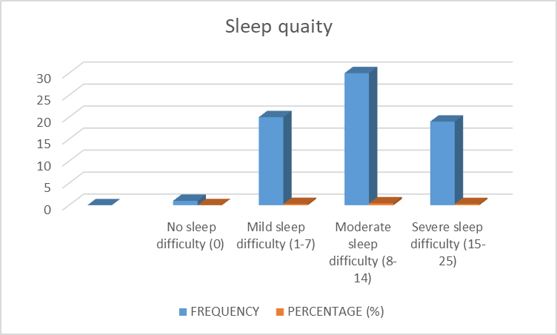
Fig. 1: Frequency distribution of sleep quality

Table 2: Type of screen is used by nursing students.
N=70
S.N. | Type of screen | f | %
 | Smartphone | 54 | 77
 | Computer | 2 | 3
 | Laptop | 4 | 6
 | Television | 10 | 14

Smartphones were the most commonly used screen device, reported by 77% of students, followed by television (14%). Only a small proportion used laptops (6%) and desktop computers (3%). These findings indicate that digital exposure among students is predominantly concentrated on mobile devices.
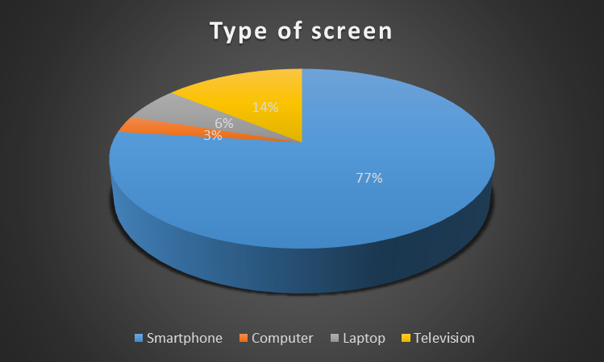
Fig 2: Type of screen used by nursing students

Table 3: Screen time( in hours) in nursing students

S.N. | Screen time | f | %
 | Less than 4 hours | 54 | 70
 | 4-6 hours | 15 | 20
 | 6-8 hours | 01 | 01
 | More than 8 hours | 07 | 09

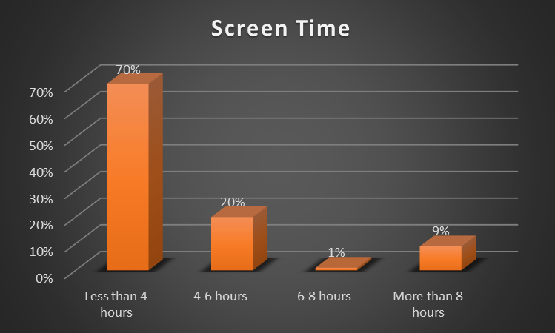

Fig 3: Screen time in nursing students
Most students (70%) reported less than 4 hours/day, while 20% reported 4–6 hours. 9% using 6-8 hours and only a small i.e.1% exceeded 6 hours . This shows that although the majority have moderate usage, a subset of students is at risk of excessive exposure.
Table 3: Sleep quality of nursing students

S.N. | Sleep Quality | Frequency | Percentage
1 | No sleep difficulty (0) | 1 | 1.42%
2 | Mild sleep difficulty (1-7) | 20 | 28.57%
3 | Moderate sleep difficulty (8-14) | 30 | 42.85%
4 | Severe sleep difficulty (15-25) | 19 | 27.14%

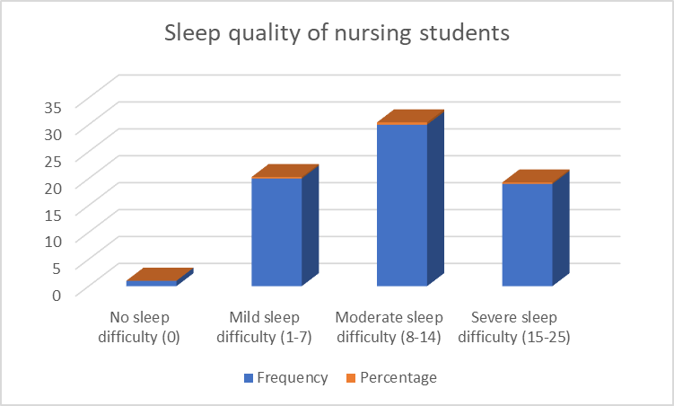
Fig 4: Sleep quality of nursing students

Table 4: Mean and SD of Screen Time and PSQI Score
Variable | N | Mean | SD
PSQI Score | 70 | 2.01 | 0.86
Screen Time | 70 | 0.27 | 0.62

The above table shows that the average PSQI score of students was 2.01, suggesting that most participants reported average to slightly poor sleep quality. The mean screen time was 0.27, which corresponds to less than 4 hours per day for most of the participants. Correlation Analysis: To test the hypothesis regarding the relationship between sleep quality and screen time, Pearson’s product-moment correlation coefficient was computed.

Table 5: Correlation between PSQI Score and Screen Time
Variable 1 | Variable 2 | N | r – value | P
PSQI | Screen Time | 70 | 0.08 | >0.05

The correlation coefficient (r = 0.08) indicates a very weak positive relationship between PSQI and screen time. The p-value is greater than 0.05, which means the correlation is not statistically significant. Thus, it can be inferred that screen time does not significantly affect sleep quality among the studied sample.

IV. DISCUSSION:
The analysis demonstrated a weak, positive, and statistically non-significant correlation between screen time and sleep quality (r = 0.08, p > 0.05). This finding indicates that, among the 70 students studied, screen time alone was not a significant determinant of sleep quality. The minimal strength of the association suggests that other psychosocial and behavioural factors may exert a more substantial influence on sleep outcomes and warrant further investigation. Liebig, L., Bergmann, A., Voigt, K. et al conducted a cross-sectional study on “Screen time and sleep among medical students in Germany.” Medical students represent a vulnerable population for adopting unhealthy behaviours due to high academic stress. Prolonged screen time has been linked to adverse health outcomes, particularly delayed sleep onset, reduced sleep duration, and impaired sleep quality. A cross-sectional, online questionnaire-based study was conducted to examine the relationship between screen time and sleep parameters among medical students at the Technical University of Dresden. Correlation coefficients, linear regression, and mixed-effects models were used for data analysis. A total of 415 students (mean age: 24 years; 70% female) participated in the study. The participants reported an average daily screen time of 7 hours and a mean sleep duration of 7.25 hours per night. Nearly one-quarter of the students (23%, n = 97) reported sleeping less than 7 hours per night, while 25% (n = 105) reported fair to very poor sleep quality. Increased leisure-related screen time was significantly associated with later bedtimes (r = 0.213, p < 0.001), whereas greater screen time spent on study or work was associated with shorter sleep duration (r = −0.108, p < 0.015). No significant association was observed statistically between total screen time and sleep quality (p = 0.103).⁵
Although existing theoretical models and prior empirical studies commonly report an adverse effect of excessive screen exposure on sleep quality—primarily through mechanisms such as circadian rhythm disruption and poor sleep hygiene—the present study did not observe a significant relationship. This difference may be explained by many factors. First, the average daily screen exposure in the sample was relatively low, with the majority of participants reporting less than four hours per day, potentially limiting its impact on sleep. Second, sleep quality is a multifactorial construct and may be more strongly affected by variables such as perceived stress, academic workload, lifestyle patterns, and environmental conditions. Finally, reliance on self-reported measures, including the Pittsburgh Sleep Quality Index (PSQI) and self-estimated screen time, may have introduced reporting bias, thereby influencing the observed association.
The present study confirms that screen time, particularly before bedtime, has a significant negative impact on sleep quality among nursing students. Implementation of sleep hygiene education and digital wellness strategies is recommended to enhance the health, academic performance, and well-being of students.
Fund received: No funding received.
Conflict of interest: No conflict of interest to declare.
Acknowledgment: The author wants to acknowledge her UG students who have supported in data collection process.

V. REFERNCES
1.Cain N, Gradisar M. Electronic media use and sleep in school-aged children and adolescents: a review. Sleep Med. 2010;11(8):735-42.
2.World Health Organization. Guidelines on physical activity, sedentary behaviour and sleep for children under 5 years of age. Geneva: WHO; 2019.
3.LeBlanc AG, et al. Canadian sedentary behaviour guidelines. Appl Physiol Nutr Metab. 2017.
4.Hale L, Guan S. Screen time and sleep among school-aged children. Sleep Med Rev. 2015; 21:50-58.
5. Liebig, L., Bergmann, A., Voigt, K. et al. Screen time and sleep among medical students in Germany. Sci Rep 13, 15462 (2023). https://doi.org/10.1038/s41598-023-42039-8

